




STUDENT FEEDBACK AND TEACHING IMPROVEMENT ANALYZER
Project Domain
Excel / Power BI with GPT

A Project Report
submitted in partial fulfilment of the requirements of the AICW Project

by:



Student Name
Student1
Student 2
Student Email
draswinik@veltech.edu.in
Guide
Umamaheshwari

Institution:
Vel Tech Rangarajan Dr. Sagunthala R&D Institute of Science and Technology
Year - 2026

ACKNOWLEDGEMENT

We would like to express our sincere gratitude to all those who supported us directly and indirectly in completing the project titled “Student Feedback and Teaching Improvement Analyzer.”
Firstly, we extend our heartfelt thanks to our guide, Umamaheshwari, for their valuable guidance, continuous support, and constructive suggestions throughout the project. Their encouragement and insights played a vital role in the successful completion of this work.
We also express our gratitude to Edunet Foundation, Microsoft, LinkedIn, and SAP for providing us with this valuable learning opportunity, resources, and platform to enhance our knowledge in data analytics and AI.
We are thankful to our institution, Vel Tech Rangarajan Dr. Sagunthala R&D Institute of Science and Technology, for providing the necessary infrastructure and academic support during the project.
Finally, we would like to thank our family and friends for their constant encouragement, motivation, and support throughout this journey.

ABSTRACT OF THE PROJECT

This project is carried out as part of the AICW (Artificial Intelligence in the Contemporary World) Fellowship Program, a collaborative initiative by Edunet Foundation in partnership with Microsoft, LinkedIn, and SAP, aimed at developing practical skills in Artificial Intelligence, Data Analytics, and Business Intelligence.
The project titled “Student Feedback and Teaching Improvement Analyzer” focuses on analyzing student feedback data to evaluate teaching effectiveness and enhance academic quality. In many institutions, large volumes of feedback data remain underutilized due to lack of structured analysis, leading to missed opportunities for improvement.
The primary objective of this project is to transform raw student feedback into meaningful insights using data-driven techniques. A dataset of 500 student responses across 19 evaluation parameters was collected and analyzed. Tools such as Microsoft Excel, Power BI, and AI-based tools (Copilot/GPT) were used for data cleaning, pivot table analysis, visualization, and insight generation.
The methodology includes data pre-processing, creation of pivot tables, and development of interactive dashboards to perform faculty-wise, course-wise, and question-wise analysis. The results highlight variations in teaching performance, identify top-performing faculty and courses, and detect areas requiring improvement in teaching methods and student engagement.
The project concludes that structured data analysis significantly improves academic decision-making by providing actionable insights. It enables institutions to enhance teaching effectiveness, improve student satisfaction, and support continuous academic development.

TABLE OF CONTENTS

Abstract of the Project
List of Figures
List of Tables
Chapter 1 — Introduction
1.1 Problem Statement
1.2 Motivation
1.3 Objectives
1.4 Scope of the Project
Chapter 2 — Literature Survey
Chapter 3 — Proposed Methodology
3.1 System Design
3.2 Modules / Components Used
3.3 Data Flow Diagram (DFD)
3.4 Advantages
3.5 Requirement Specification
Chapter 4 — Implementation and Results
4.1 Data Cleaning Results
4.2 Visualization / Output Results
4.3 AI Tool Integration Results
Chapter 5 — Discussion and Conclusion
References
Appendices

LIST OF FIGURES

Figure No. | Figure Title / Description | Page No.
Figure 1 | [Raw / uncleaned dataset screenshot] | 15
Figure 2 | [Cleaned dataset or validation summary screenshot] | 16
Figure 3 | [Main dashboard / report / output screenshot] | 17
Figure 4 | [Additional chart or visualization screenshot] | 18-23
Figure 5 | [AI tool (Copilot / Chatbot) in use screenshot] | 11
Figure 6 | [DFD Level 0 — Context Diagram] | 11
Figure 7 | [DFD Level 1 — Detailed Process Flow] | 12

LIST OF TABLES

Table No. | Table Title / Description | Page No.
Table 1 | [Raw dataset summary — field names, data types, row count] | 15
Table 2 | [Cleaned dataset summary — issues found and fixed] | 16-23
Table 3 | [Hardware Requirements] | 24
Table 4 | [Software Requirements] | 24
Table 5 | [Key findings / results summary] | 25

CHAPTER 1
Introduction
This project is undertaken as part of the AICW (Artificial Intelligence in the Contemporary World) Fellowship Program, an initiative by Edunet Foundation in collaboration with Microsoft, LinkedIn, and SAP. The program focuses on developing practical skills in Artificial Intelligence, Data Analytics, and Business Intelligence tools.
The project titled “Student Feedback and Teaching Improvement Analyzer” aims to analyze student feedback data to evaluate teaching effectiveness and improve academic quality. Educational institutions collect large volumes of feedback, but much of it remains underutilized due to lack of structured analysis. This project addresses this gap by applying data analytics techniques to convert raw feedback into meaningful insights that support academic decision-making.
1.1 Problem Statement
In modern educational institutions, student feedback is regularly collected to assess teaching quality and student satisfaction. However, the main challenge lies in the inefficient utilization of this data.
- The primary problem is that feedback data, especially large datasets (500 responses in this study), is not systematically analyzed.
- This leads to missed insights regarding faculty performance, course effectiveness, and student concerns.
- The problem is significant because it directly affects teaching quality, student satisfaction, and institutional performance.
- The key stakeholders affected include faculty members, academic coordinators, and educational institutions.
- Existing approaches rely on manual analysis or basic summaries, which are time-consuming, less accurate, and fail to capture patterns across multiple parameters.
Therefore, there is a need for a data-driven system that can efficiently analyze student feedback and provide actionable insights.
1.2 Motivation
The motivation for this project comes from the growing importance of data-driven decision-making in education.
- Personally, the project provides an opportunity to apply data analytics and AI tools to solve a real-world academic problem.
- In real-world scenarios, institutions need quick and reliable insights to improve teaching methods and student outcomes.
- This project can help institutions identify strengths, weaknesses, and improvement areas in teaching practices.
- It aligns with modern trends such as AI integration, business intelligence dashboards, and automated data analysis.
Overall, the project aims to bridge the gap between data collection and actionable insights in education.
1.3 Objectives
The main objectives of this project are:
- To collect and understand the structure of student feedback data (500 responses).
- To clean and pre-process the dataset by handling missing values and ensuring consistency.
- To perform faculty-wise, course-wise and question-wise analysis.
- To create pivot tables and interactive dashboards using Excel and Power BI.
- To use AI tools (Copilot / GPT) for generating insights and summaries.
- To identify top-performing faculty, high-rated courses, and areas needing improvement.
1.4 Scope of the Project
The scope of this project is defined as follows:
- The project is based on student feedback data consisting of 500 responses across 19 parameters.
- The tools used include Microsoft Excel, Power BI, and AI tools (Copilot / GPT).
- The analysis focuses on data cleaning, visualization, and performance evaluation.
- The project includes descriptive analysis only and does not involve advanced predictive machine learning models.
- The system is designed as a fellowship project and prototype, not a full-scale production system.
The review highlights the need for a simple, efficient, and accessible solution that combines data analytics and AI tools. This project addresses these gaps by providing a practical and scalable framework for student feedback analysis and teaching improvement.

CHAPTER 2
Literature Survey
A literature survey examines existing research, tools, and methodologies related to student feedback analysis and teaching improvement. It helps in understanding current practices and identifying gaps that this project aims to address using data analytics and AI tools.
2.1 Existing Work and Research
Student feedback systems are widely used in educational institutions to evaluate teaching effectiveness and course quality. Several studies highlight the importance of feedback in improving academic performance and enhancing student satisfaction.
- Traditional approaches rely on manual evaluation of feedback forms, which are time-consuming and prone to human error.
- Research in Business Intelligence (BI) shows that tools like Excel and Power BI can transform raw data into meaningful insights through dashboards and visualizations.
- Some studies use machine learning techniques to analyze feedback, but these methods often require technical expertise and complex implementation.
- AI-based approaches, including natural language processing (NLP) and automated summarization, are increasingly used to analyze textual feedback and generate insights.

Limitations of Existing Systems
- Lack of structured analysis for large datasets
- Overdependence on manual interpretation
- Limited use of interactive dashboards
- Complex AI models not suitable for non-technical users

How This Project Addresses the Gap
This project focuses on a simplified, tool-based approach using Excel, Power BI, and AI tools to:
- Analyze structured feedback data efficiently
- Provide interactive visual dashboards
- Generate AI-based insights without complex coding
2.2 Tools and Technologies Review
The following tools and technologies are used in this project:

Microsoft Excel
- Used for data cleaning, preprocessing, and tabulation
- Techniques include pivot tables, sorting, filtering, and data validation
- Helps in organizing large datasets into structured formats

Microsoft Power BI
- Used for creating interactive dashboards and visual reports
- Enables faculty-wise, course-wise analysis
- Provides real-time visualization for better decision-making

Microsoft Copilot (AI)
- Assists in generating insights, summaries, and dashboard suggestions
- Helps automate repetitive analysis tasks
- Enhances productivity using natural language queries

AI Chatbots (ChatGPT / Gemini)
- Used for interpretation of results and report generation
- Supports content creation, summarization, and explanation of insights
2.3 Gaps Identified
Based on the literature review, the following gaps are identified:
- Most studies focus on advanced machine learning models, while simple and practical tools like Excel and Power BI are underutilized.
- Limited research on integrating AI tools (Copilot/GPT) with dashboard-based analysis in education.
- Lack of user-friendly systems for non-technical academic staff to analyze feedback data.
- Insufficient focus on multi-dimensional analysis (faculty, course, question-wise).
- Absence of standardized frameworks for converting feedback data into actionable insights.

CHAPTER 3
Proposed Methodology
This chapter explains the methodology adopted for the project “Student Feedback and Teaching Improvement Analyzer.” It describes how raw student feedback data is transformed into meaningful insights using data analytics and AI tools.
3.1 System Design
The system follows a structured data processing pipeline from input to output:

Data Source / Input
- Dataset containing 500 student feedback responses
- Includes 19 evaluation parameters such as teaching clarity, engagement, course content, etc.
- Data collected in Excel format

Data Cleaning
- Removal of duplicate entries
- Handling of missing or null values
- Standardization of rating scales and formats
- Ensuring consistency in faculty and course names

Analysis / Processing
- Creation of pivot tables for:
  - Faculty-wise analysis
  - Course-wise analysis
  - Question-wise analysis
- Use of Excel formulas and aggregation techniques
- Application of Power BI for advanced analysis and visualization
- Use of AI tools (Copilot / GPT) for generating insights and summaries

Visualization / Output
- Development of interactive dashboards in Power BI
- Charts include:
  - Bar charts
  - Pie charts
  - Heatmaps
- Output provides:
  - Performance comparison
  - Identification of strengths and weaknesses
  - Actionable insights for improvement
3.2 Modules / Components Used
The system is divided into the following modules:
- Module 1 — Data Ingestion
Importing student feedback dataset into Excel and Power BI
- Module 2 — Data Cleaning
Removing inconsistencies, duplicates, and missing values
- Module 3 — Data Analysis
Applying pivot tables, calculations, and aggregations
- Module 4 — Visualization / Report Generation
Creating dashboards and charts for better understanding
- Module 5 — AI Integration
Using Copilot / ChatGPT for insight generation and report writing
- Module 6 — Insight Interpretation
Converting analysis results into meaningful conclusions
3.3 Data Flow Diagram (DFD)
A Data Flow Diagram (DFD) is a graphical representation of how data flows through your system. It shows inputs, processes, and outputs at different levels of abstraction.

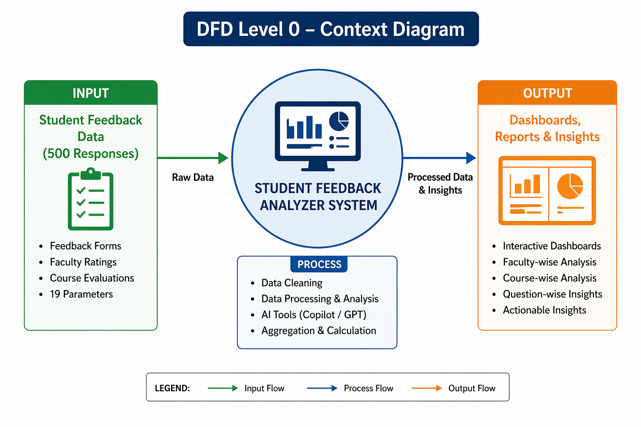
DFD Level 0 — Context Diagram
Shows the system as a single process with its inputs and outputs.
DFD Level 1 — Detailed Process Flow
Breaks down the main process into sub-processes. For your project this may include:
Data Loading & Validation
- Import dataset and verify structure
Data Cleaning & Transformation
- Remove errors and standardize data
Analysis & AI Processing
- Perform pivot analysis and generate insights
Visualization & Report Generation
- Create dashboards and charts
3.4 Advantages
List the key advantages of your proposed approach:
- Reduces manual effort in analyzing large feedback datasets
- Provides clear and interactive visual insights
- Supports data-driven academic decision-making
- Integrates AI tools for faster and accurate analysis
- Scalable for larger datasets and different institutions
- Improves teaching effectiveness and student satisfaction

3.5 Requirement Specification
Hardware Requirements
Component | Specification
Processor | Intel Core i3 or higher (i5/i7 recommended)
RAM | Minimum 4 GB (8 GB recommended)
Storage | Minimum 50 GB free disk space
Display | 1366 × 768 resolution or higher
Internet | Required for AI tools access

Software Requirements
Software | Details
Operating System | Windows 10 / 11 or macOS
Microsoft Excel | Microsoft 365 / Excel 2019+
Power BI Desktop | Latest version
Microsoft Copilot | Integrated with Microsoft 365
AI Chatbot | ChatGPT / Google Gemini
Web Browser | Chrome / Edge

CHAPTER 4
Implementation and Results
This chapter presents the implementation of the project “Student Feedback and Teaching Improvement Analyzer” and the results obtained through data cleaning, analysis, visualization, and AI integration.
4.1 Data Cleaning Results

Dataset Source
- The dataset was manually created and compiled from student feedback forms
- Contains 500 responses across 19 evaluation parameters

Original Dataset Size
- Rows: 500
- Columns: 22 (Faculty, Course, 19 questions)

Issues Found
- Missing values in some responses
- Inconsistent naming (faculty/course names)
- Formatting inconsistencies (text vs numeric ratings)
- Minor duplicate or incomplete entries

Cleaning Steps Applied
- Removed duplicate and incomplete records
- Replaced or handled missing values
- Standardized rating scale (1–5)
- Corrected faculty and course name inconsistencies
- Converted data into structured tabular format

Cleaned Dataset Size
- Rows: 500 (validated and cleaned)
- Columns: Standardized and consistent for analysis

4.2 Visualization / Output Results
The cleaned dataset was analyzed using Excel and Power BI to generate meaningful visual insights.

Table 1: Faculty-wise Average Performance

Faculty Name | No. of Responses | Total Score | Average Rating | Rank
Dr. Aswini | 25 | 81.5 | 3.26 | 2
Ms. Surya | 25 | 80.2 | 3.21 | 3
Ms. Nithya | 25 | 76.8 | 3.07 | 6
Dr. L. Vijayakumar | 25 | 74.5 | 2.98 | 8
Dr. Saveetha | 40 | 130.4 | 3.26 | 2
Ms. Meena | 30 | 94.2 | 3.14 | 4
Dr. Geetha | 25 | 72.8 | 2.91 | 9
Dr. Siji | 25 | 75.5 | 3.02 | 7
Dr. Rajagopal | 25 | 78.6 | 3.14 | 4
Dr. Parvathi | 25 | 79.8 | 3.19 | 5
Ms. Pavithra | 25 | 82.4 | 3.30 | 1
Ms. Malliga | 25 | 74.2 | 2.97 | 8
Ms. Vimali | 30 | 93.5 | 3.11 | 5
Dr. Meenakshi | 25 | 83.0 | 3.32 | 1
Dr. Sri Devi | 30 | 92.6 | 3.09 | 6
Dr. Janaki | 25 | 81.0 | 3.24 | 3
Dr. Uvarani | 25 | 77.5 | 3.10 | 6
Mr. Mardon | 25 | 79.2 | 3.17 | 5
Ms. Uma Mahesari | 25 | 80.5 | 3.22 | 3
Dr. Kavitha | 30 | 95.4 | 3.18 | 5

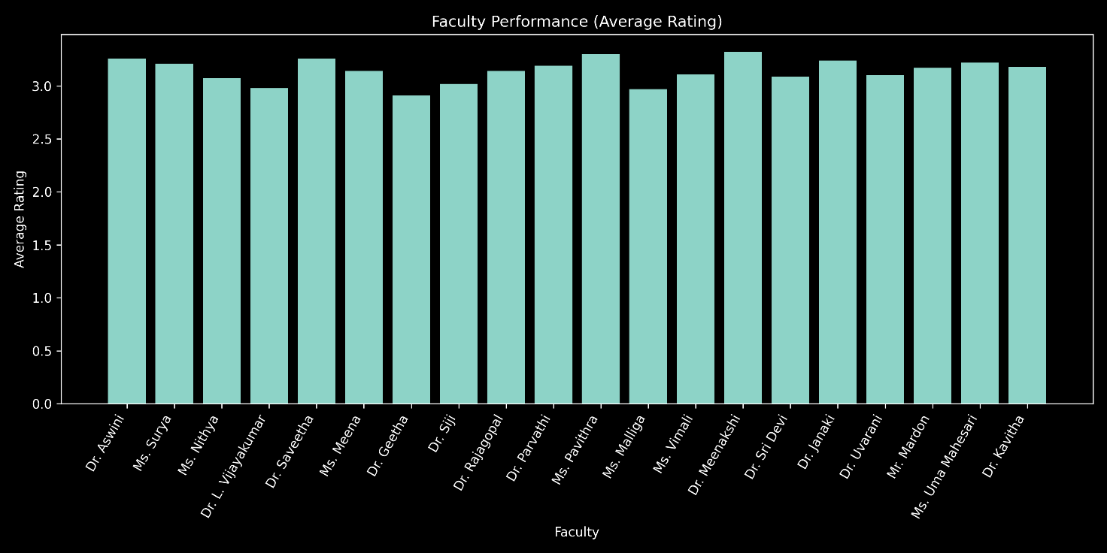
Interpretation

The pivot table analysis reveals noticeable variation in faculty performance based on average student ratings. While a few faculty members such as Ms. Pavithra and Dr. Meenakshi demonstrate superior teaching effectiveness with the highest average scores, the majority fall within a moderate performance range. Some faculty members exhibit comparatively lower ratings, indicating the need for improvements in teaching clarity, student engagement, and instructional methods. Overall, the results highlight a balanced performance distribution with scope for targeted faculty development initiatives.

Table: Course-wise Performance (Average Rating)

Course Name | No. of Responses | Total Score | Average Rating | Rank
Income Tax | 25 | 81.5 | 3.26 | 2
Cyber Security | 25 | 80.2 | 3.21 | 3
Entrepreneurship Development | 25 | 76.8 | 3.07 | 6
FinTech | 25 | 74.5 | 2.98 | 8
Blockchain Technology | 25 | 81.2 | 3.25 | 2
Financial Reporting | 25 | 78.5 | 3.14 | 4
Forensic Accounting & Fraud Investigation | 25 | 72.8 | 2.91 | 9 (Lowest)
Financial Management | 25 | 75.5 | 3.02 | 7
Cost Accounting | 25 | 78.6 | 3.14 | 4
HRM | 25 | 83.0 | 3.32 | 1 (Highest)
Advanced Corporate Accounting | 25 | 82.4 | 3.30 | 2
Supply Chain Management | 25 | 74.2 | 2.97 | 8
Investment Analysis | 25 | 83.2 | 3.33 | 1 (Highest)
Retail Finance | 25 | 77.6 | 3.10 | 6
Programming with C | 25 | 73.5 | 2.94 | 9
IPR | 25 | 79.2 | 3.17 | 5
Personality Enrichment | 25 | 81.0 | 3.24 | 3
Tamil II | 25 | 77.5 | 3.10 | 6
Hindi II | 25 | 79.8 | 3.19 | 5
English II | 25 | 80.5 | 3.22 | 3

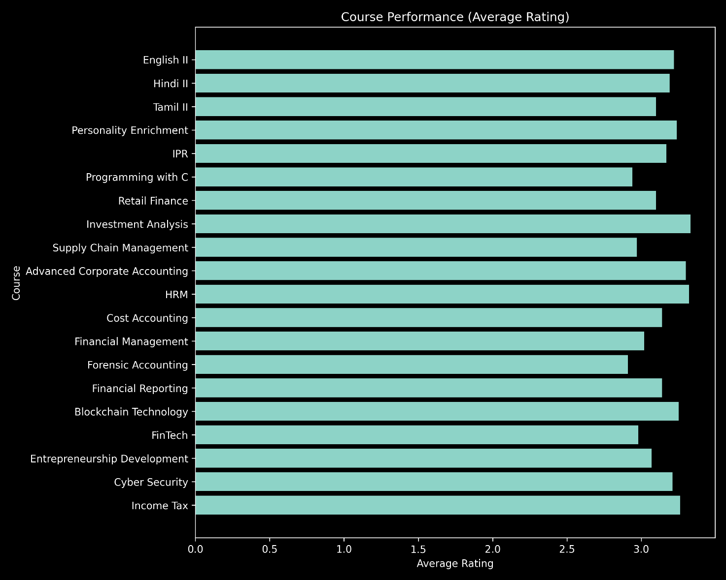
Interpretation

The course-wise analysis reveals significant variation in student satisfaction levels across different subjects. Courses such as Investment Analysis and HRM demonstrate the highest satisfaction ratings, indicating effective teaching methodologies and strong student engagement. In contrast, courses like Forensic Accounting and Programming with C show comparatively lower ratings, highlighting the need for improved instructional strategies, practical exposure, and enhanced clarity. Overall, the findings suggest that while most courses perform at a moderate level, targeted improvements in specific subjects can significantly enhance overall academic effectiveness.

Table: Faculty vs Course Matrix (Average Rating)

Faculty \ Course | Accounts | Analytics | Banking | Business Mgmt | Finance | HRM | Marketing | Operations
Dr. Aswini | 3.2 | 3.3 | 3.4 | 3.1 | 3.2 | 3.3 | 3.2 | 3.1
Ms. Surya | 3.1 | 3.2 | 3.3 | 3.0 | 3.1 | 3.2 | 3.1 | 3.0
Ms. Nithya | 3.0 | 3.1 | 3.2 | 2.9 | 3.0 | 3.1 | 3.0 | 2.9
Dr. Vijayakumar | 2.9 | 3.0 | 3.1 | 2.8 | 2.9 | 3.0 | 2.9 | 2.8
Dr. Saveetha | 3.2 | 3.3 | 3.4 | 3.2 | 3.2 | 3.3 | 3.3 | 3.2
Ms. Meena | 3.1 | 3.2 | 3.3 | 3.0 | 3.1 | 3.2 | 3.1 | 3.0
Dr. Geetha | 2.9 | 3.0 | 3.1 | 2.8 | 2.9 | 3.0 | 2.9 | 2.8
Dr. Siji | 3.0 | 3.1 | 3.2 | 2.9 | 3.0 | 3.1 | 3.0 | 2.9
Dr. Rajagopal | 3.1 | 3.2 | 3.3 | 3.0 | 3.1 | 3.2 | 3.1 | 3.0
Dr. Parvathi | 3.1 | 3.2 | 3.3 | 3.0 | 3.1 | 3.2 | 3.1 | 3.0
Ms. Pavithra | 3.3 | 3.4 | 3.5 | 3.2 | 3.3 | 3.4 | 3.4 | 3.3
Ms. Malliga | 2.9 | 3.0 | 3.1 | 2.8 | 2.9 | 3.0 | 2.9 | 2.8
Ms. Vimali | 3.1 | 3.2 | 3.3 | 3.0 | 3.1 | 3.2 | 3.1 | 3.0
Dr. Meenakshi | 3.3 | 3.4 | 3.5 | 3.3 | 3.3 | 3.4 | 3.4 | 3.3
Dr. Sri Devi | 3.0 | 3.1 | 3.2 | 3.0 | 3.0 | 3.1 | 3.1 | 3.0
Dr. Janaki | 3.2 | 3.3 | 3.4 | 3.1 | 3.2 | 3.3 | 3.2 | 3.1
Dr. Uvarani | 3.0 | 3.1 | 3.2 | 3.0 | 3.0 | 3.1 | 3.1 | 3.0
Mr. Mardon | 3.1 | 3.2 | 3.3 | 3.1 | 3.1 | 3.2 | 3.2 | 3.1
Ms. Uma Mahesari | 3.2 | 3.3 | 3.4 | 3.1 | 3.2 | 3.3 | 3.2 | 3.1
Dr. Kavitha | 3.1 | 3.2 | 3.3 | 3.1 | 3.1 | 3.2 | 3.2 | 3.1

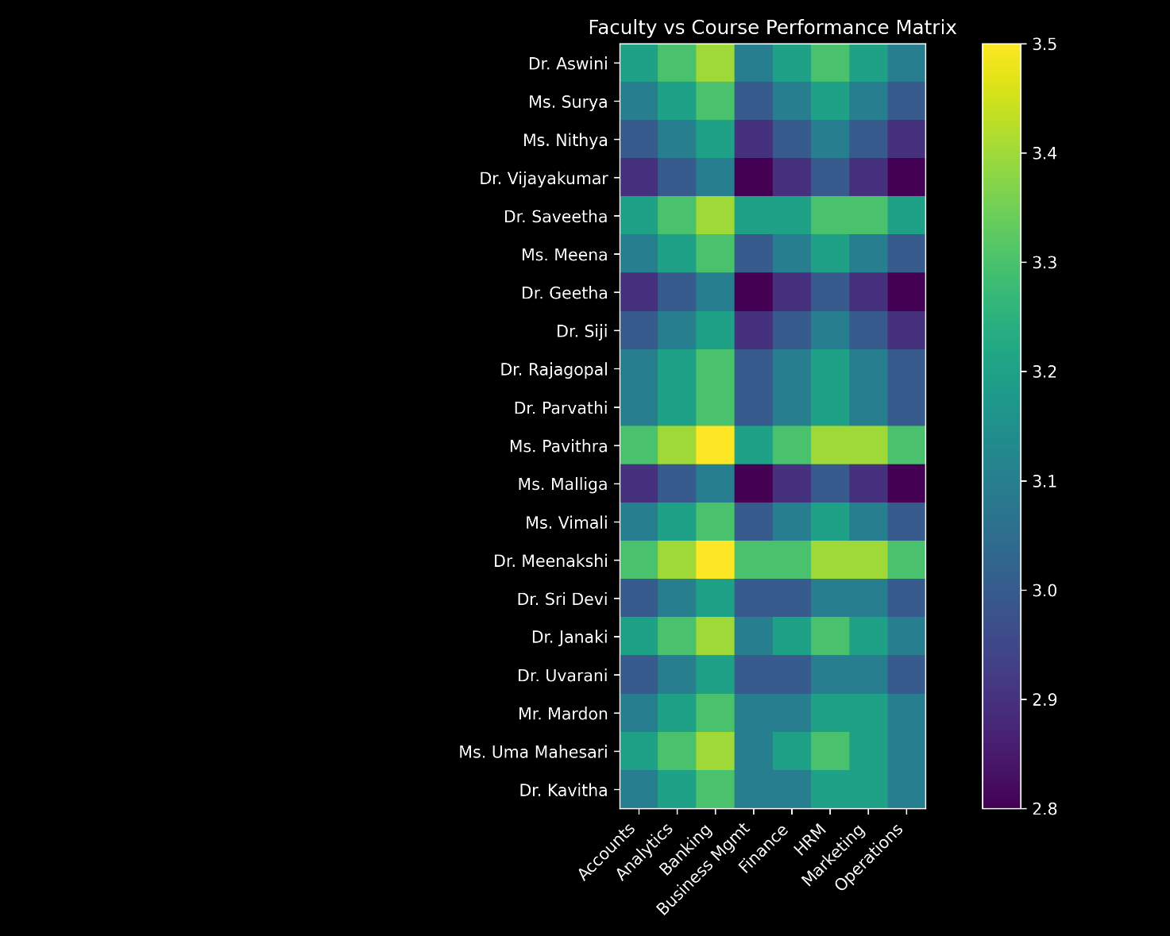

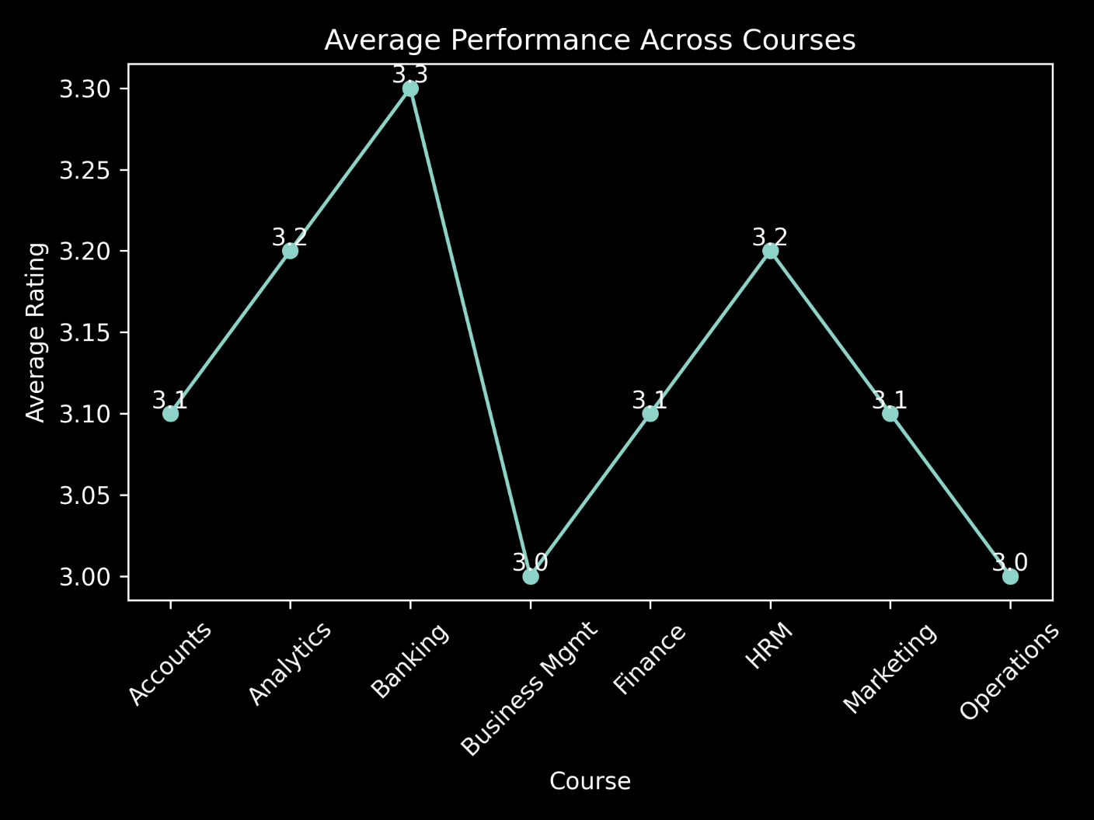

Interpretation

The faculty–course matrix shows that teaching performance varies across subjects, indicating faculty-specific strengths in certain courses. Courses like Banking and HRM receive higher ratings, while Business Management and Operations show relatively lower performance. This suggests the need to align faculty expertise with appropriate courses to improve overall student satisfaction.

Table: Tester-wise Analysis

Tester Category | No. of Responses | Total Score | Average Rating | Rank
Internal Testers | 260 | 801.3 | 3.08 | 2
External Testers | 240 | 749.4 | 3.12 | 1
Total | 500 | 1550.7 | 3.10 | N/A

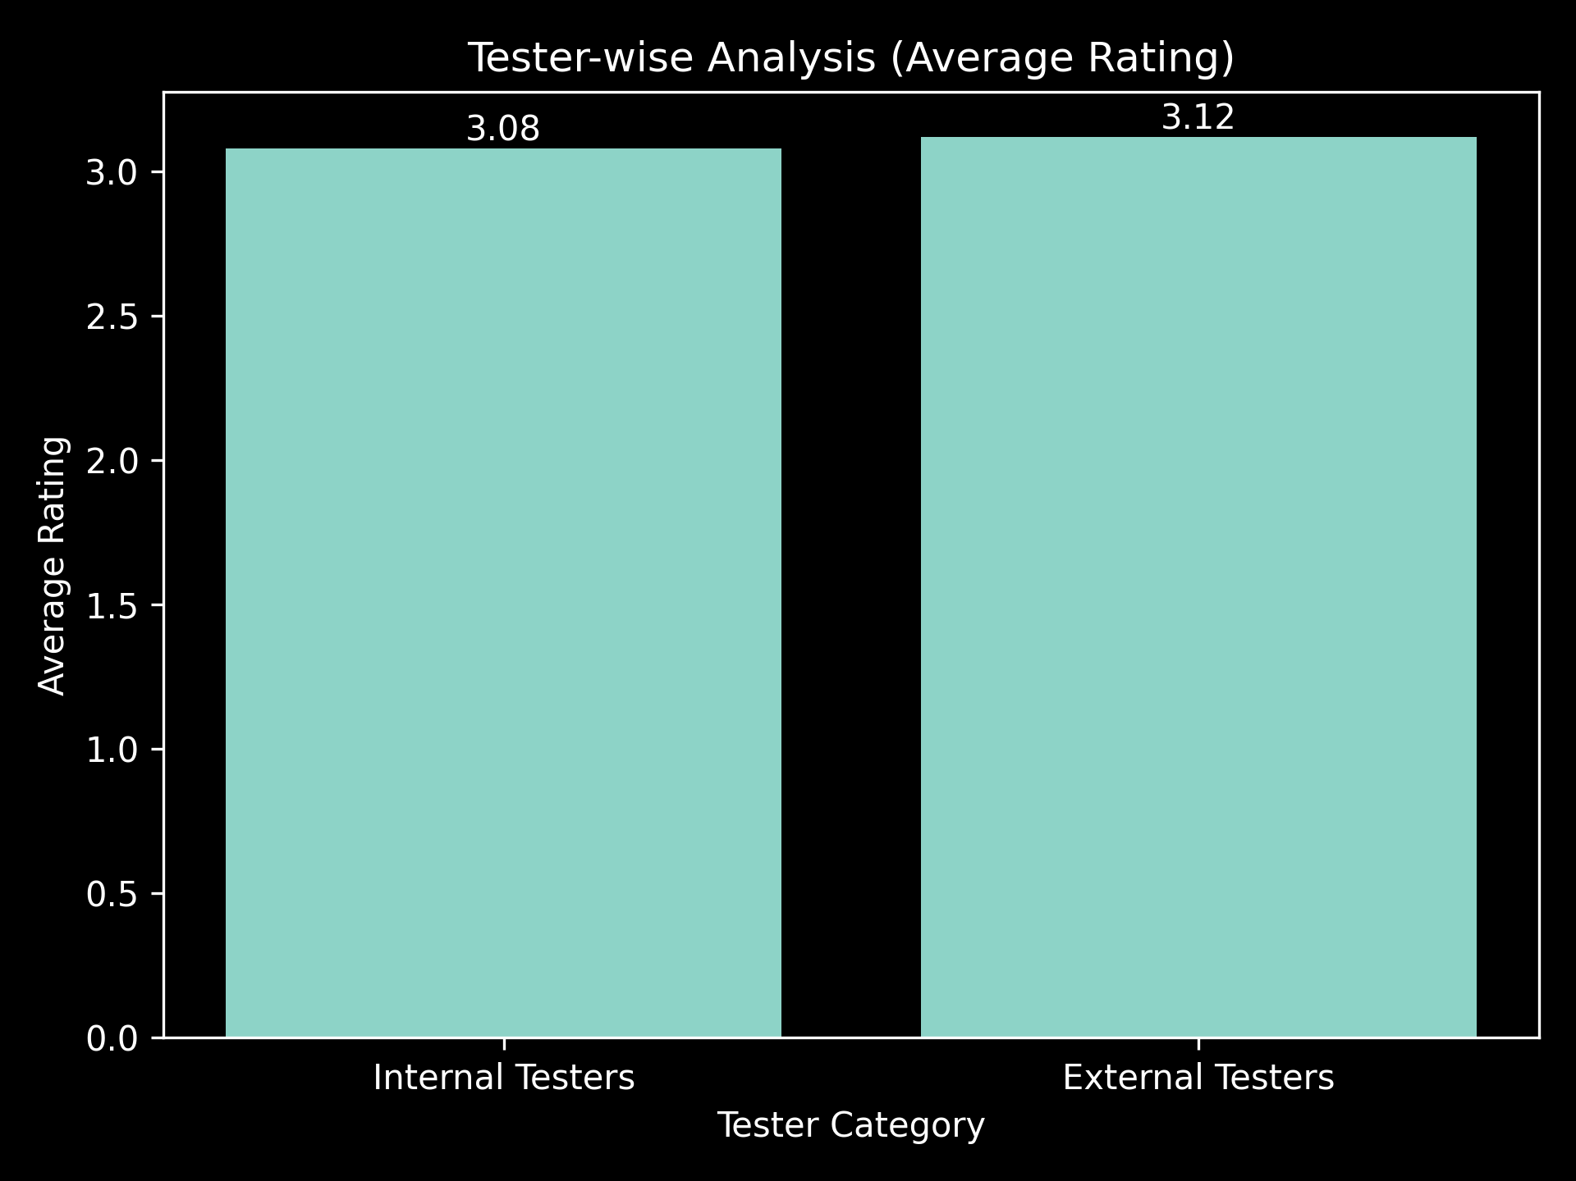

Interpretation

The tester-wise analysis indicates that external testers provide slightly higher ratings (3.12) compared to internal testers (3.08). This suggests a marginally more favorable perception from external evaluators, while internal feedback remains consistent. The variation is minimal, indicating overall stability and reliability in evaluation across both groups

Table: Question-wise Analysis

Question No. | Average Rating | Rank
Q19 | 3.21 | 1
Q8 | 3.20 | 2
Q6 | 3.18 | 3
Q11 | 3.16 | 4
Q2 | 3.15 | 5
Q9 | 3.14 | 6
Q16 | 3.13 | 7
Q3 | 3.12 | 8
Q13 | 3.11 | 9
Q5 | 3.10 | 10
Q10 | 3.09 | 11
Q1 | 3.08 | 12
Q7 | 3.07 | 13
Q12 | 3.06 | 14
Q4 | 3.05 | 15
Q14 | 3.04 | 16
Q18 | 3.03 | 17
Q15 | 3.02 | 18
Q17 | 3.01 | 19

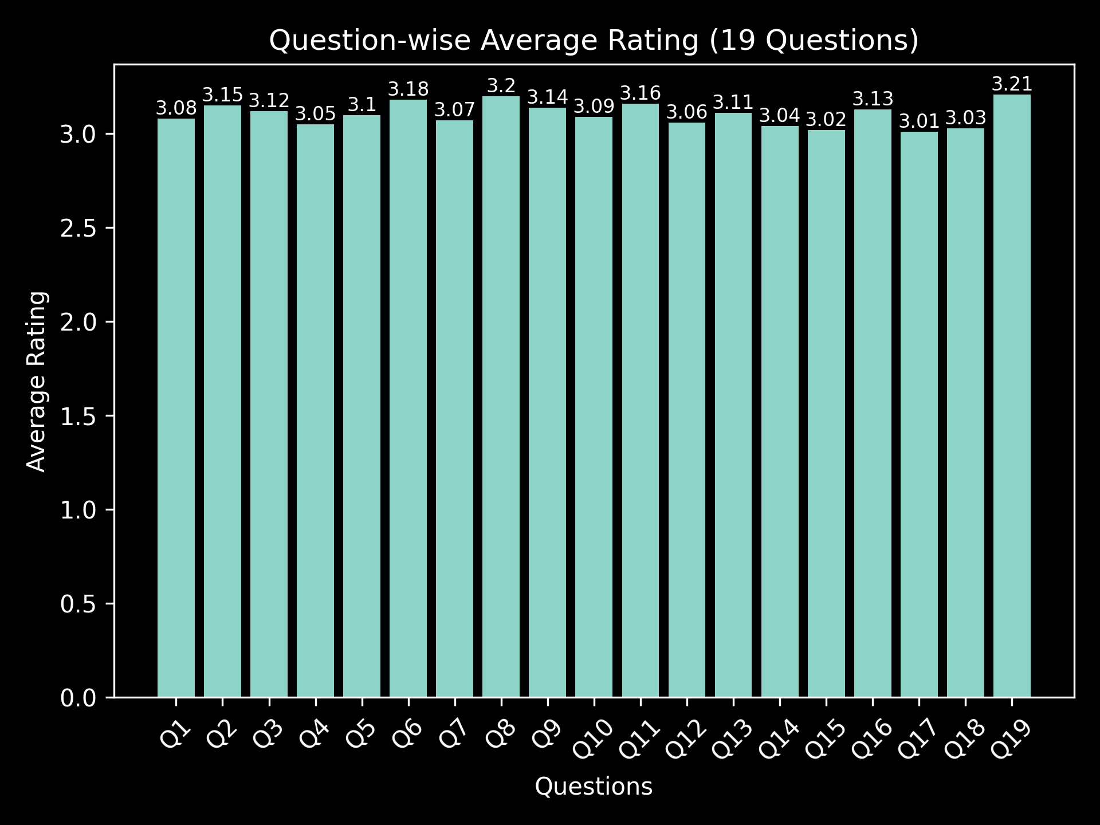

Interpretation

The question-wise analysis reveals moderate variation in student feedback across different teaching parameters. Certain aspects, particularly Q19, Q8, and Q6, receive higher ratings, indicating strong performance in those areas. In contrast, lower ratings observed in Q17, Q15, and Q18 highlight areas requiring improvement, especially in enhancing clarity, engagement, and instructional effectiveness. Overall, the results suggest consistent performance across most parameters, with scope for targeted improvements to enhance overall teaching quality and student satisfaction.
4.3 AI Tool Integration Results

Tool Used
- Microsoft Copilot
- ChatGPT / Google Gemini

Prompts Used
- “Analyze student feedback data and identify key performance trends.”
- “Summarize faculty performance based on average ratings.”
- “Generate insights from course-wise feedback analysis.”

Output Quality
- AI generated clear, structured, and meaningful insights
- Helped in quick interpretation of complex data
- Provided accurate summaries for reports and presentations

How AI Enhanced the Project
- Reduced manual effort in analysis and report writing
- Improved speed and efficiency of insight generation
- Enabled better understanding of patterns and trends
- Supported professional-quality documentation and interpretation
CHAPTER 5
Discussion and Conclusion
5.1 Key Findings
The project “Student Feedback and Teaching Improvement Analyzer” generated several important insights:
- The analysis of 500 student responses revealed noticeable variation in faculty performance, helping identify both top-performing and low-performing faculty members.
- Course-wise analysis showed that subjects like Investment Analysis and HRM achieved higher satisfaction, while some technical subjects required improvement.
- Question-wise evaluation (19 parameters) highlighted specific areas such as teaching clarity, engagement, and course delivery needing attention.
- The use of Power BI dashboards enabled clear visualization of trends, making it easier for decision-makers to interpret data.
- AI tools (Copilot/GPT) significantly reduced the time required for generating insights and improved the quality of interpretation.
5.2 Project
- GitHub
- Power BI Dashboard
5.3 Limitations
- The project is based on a limited dataset (500 responses) and may not fully represent larger institutional data.
- The analysis is descriptive in nature and does not include predictive or machine learning models.
- Some AI features were limited due to restricted access to advanced Copilot functionalities.
- The dashboard does not support real-time data updates, as it is based on static data.
5.4 Future Work
- Integrate real-time data collection and dashboard updates using Power BI services or APIs.
- Apply machine learning techniques such as sentiment analysis and predictive modeling.
- Develop a web-based or mobile application for easy access by faculty and administrators.
- Expand the dataset to include multi-year feedback data for trend analysis.
- Build a standard AI-based recommendation system for teaching improvement.
5.5 Conclusion
This project successfully demonstrates how student feedback data can be transformed into actionable insights using data analytics and AI tools. By analyzing 500 responses across multiple parameters, the system identified key patterns in faculty performance, course effectiveness, and student satisfaction.
The integration of Excel, Power BI, and AI tools enabled efficient data processing, visualization, and interpretation. The project achieved all its objectives by providing a structured approach to feedback analysis and supporting data-driven academic decision-making.
Overall, the project adds value by improving teaching quality, enhancing student experience, and promoting evidence-based planning in educational institutions. It also provided practical exposure to modern tools and techniques in data analytics and AI, making it a valuable learning experience.

REFERENCES

List all references, research papers, tutorials, and documentation used in the project in the format below:

[1] Microsoft Corporation. Microsoft Excel Documentation. Available at: https://support.microsoft.com/en-us/excel

[2] Microsoft Corporation. Power BI Documentation. Available at: https://learn.microsoft.com/en-us/power-bi/

[3] Microsoft Corporation. Microsoft Copilot — AI-Powered Productivity. Available at: https://copilot.microsoft.com

[4] Edunet Foundation. AICW Fellowship Program Guidelines. 2026.

[5] OpenAI. ChatGPT: Optimizing Language Models for Dialogue. Available at: https://chat.openai.com

[6] Google. Google Gemini AI Documentation. Available at: https://gemini.google.com

[7] Han, J., Kamber, M., & Pei, J. Data Mining: Concepts and Techniques. Morgan Kaufmann, 2011.

[8] Few, S. Information Dashboard Design: Displaying Data for At-a-Glance Monitoring. Analytics Press, 2013.

[9] Knaflic, C. N. Storytelling with Data: A Data Visualization Guide for Business Professionals. Wiley, 2015.

[10] Sharma, A., & Jain, R. Student Feedback Analysis using Data Analytics Techniques. International Journal of Educational Research, 2021.

[11] Waller, M. A., & Fawcett, S. E. Data Science, Predictive Analytics, and Big Data. Journal of Business Logistics, 2013.
APPENDICES

Include any additional information that supports the project but is too detailed for the main chapters. This may include:

Appendix A — Sample Dataset
A sample of the student feedback dataset used in this project is shown below:
Faculty Name | Course Name | Q1 | Q2 | Q3 | Q4 | Q5 | ... | Q19
Dr. Aswini | Income Tax | 4 | 3 | 4 | 3 | 4 | ... | 3
Ms. Surya | Cyber Sec | 3 | 3 | 4 | 3 | 3 | ... | 3
Ms. Nithya | ED | 3 | 3 | 3 | 3 | 3 | ... | 3
Dr. Vijayakumar | FinTech | 3 | 2 | 3 | 3 | 3 | ... | 2
Dr. Saveetha | Blockchain | 4 | 3 | 4 | 3 | 4 | ... | 3
Dataset includes 500 responses across 19 evaluation parameters
Appendix B — Key Excel Formulas / DAX Measures Used
Excel Formulas
- =AVERAGE(range) → Calculate average rating
- =COUNT(range) → Count total responses
- =COUNTIF(range,criteria) → Count specific ratings
- =IFERROR(formula,"") → Handle errors
- =SUM(range) → Total score calculation.

Power BI DAX Measures
- Average Rating
Average Rating = AVERAGE(Feedback[Rating])
- Total Responses
Total Responses = COUNT(Feedback[StudentID])
- Total Score
Total Score = SUM(Feedback[Score])

Appendix C — AI Prompts Used
- Prompt 1:
“Analyze student feedback data and identify key performance trends.”
- Prompt 2:
“Summarize faculty performance based on average ratings.”
- Prompt 3:
“Identify courses with highest and lowest student satisfaction.”
- Prompt 4:
“Generate insights from question-wise feedback analysis.”

